**Real Case Scenario**

Taylor is an IT learner. His boss asked him to check if the virtual machine he just set up has internet connectivity and provided a specific DNS domain for this task. Additionally, Taylor needs to set up the ticketing system he will use for every request assigned to him.

Ticketing system: [Sign in to Zendesk](https://www.zendesk.com/login/)  
  
**Process:** The first thing we’re going to do is confirm that our virtual machine has internet access. We’ll do this by pinging a DNS server to check the packets and verify our configuration.

We are going to open the Command Prompt (CMD) and use the ping command. Then, we will add the DNS domain, which is 8.8.8.8, and press Enter.

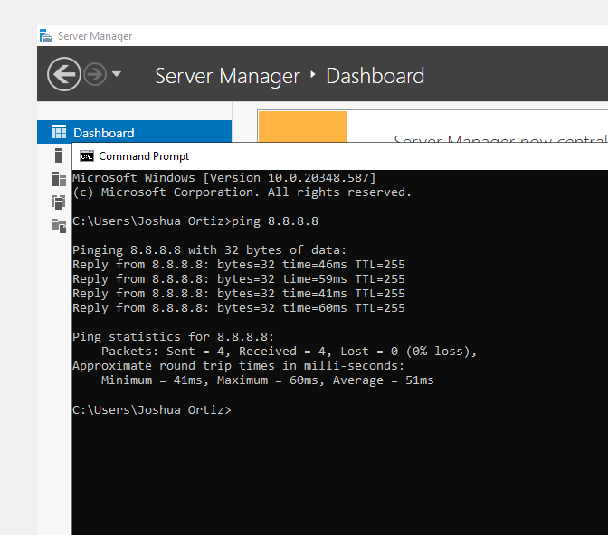

The ping command is a network utility used to test the reachability of a host on an IP network. It works by sending Internet Control Message Protocol (ICMP) Echo Request messages to the target host and waiting for Echo Reply messages. Here’s a detailed explanation of what the ping command does:

**Functions of the ping Command:**

1. **Verifies Connectivity:**
   * The primary purpose of ping is to check if a specific IP address or domain name is reachable. It helps verify that the target device is online and can communicate over the network.
2. **Measures Round-Trip Time:**
   * ping measures the time it takes for the Echo Request message to reach the target and for the Echo Reply message to return. This round-trip time is displayed in milliseconds, providing an indication of network latency.
3. **Troubleshoots Network Issues:**
   * By using ping, you can identify network issues such as packet loss, high latency, or unreachable hosts. It’s a fundamental tool for diagnosing connectivity problems.
4. **Name Resolution:**
   * ping can also be used to test DNS name resolution. By pinging a domain name (e.g., ping www.google.com), you can verify that the domain name is correctly resolved to an IP address.

**Example Usage:**

ping 8.8.8.8

* This command sends ICMP Echo Request messages to the IP address 8.8.8.8 (Google’s public DNS server) and waits for replies.

**Output Explanation:**

* **Packets Sent/Received:** Indicates the number of packets sent and received, helping to identify packet loss.
* **Round-Trip Time:** Shows the minimum, maximum, and average time taken for the packets to travel to the target and back.
* **TTL (Time to Live):** Indicates the remaining lifespan of the packet, which decreases as the packet traverses network devices.

**Practical Applications:**

* **Network Diagnostics:** Quickly check if a server or device is reachable.
* **Performance Monitoring:** Measure network latency and identify potential bottlenecks.
* **DNS Testing:** Verify that domain names are correctly resolved to IP addresses.